**Kaohsiung Medical University**

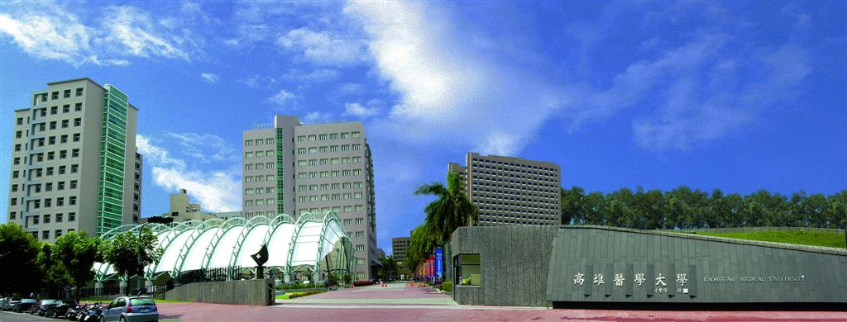

**University Website: https://www.kmu.edu.tw/index.php/en-gb/**

**Address:** No.100, Shih-Chuan 1st Road, Sanmin District, Kaohsiung City,80708, Taiwan

**Main Phone:** +886 7 312-1101

**President:** Chun-Yuh Yang

**Institutional Description**

Kaohsiung Medical University (KMU) was established in 1954 as Kaohsiung Medical College in downtown Kaohsiung, a well-known harbor city for its oceanic scenery. Apart from being the first private medical university in Taiwan, it has become an essential cradle for highly skilled physicians and medical-related specialists. In the early years, KMU served as a center for medical care and local tropical medicine study.

After the World Health Organization announced its intention to delist Taiwan from the tropical disease endemic area, the college lifted its tropical disease research mission and evolved to focus on basic medical science and clinical medical research. For over 70 years, the university has continued to improve and strengthen its medical services. As a result, KMU has laid a solid foundation as the leading medical institution in Sothern Taiwan.

Being reformed to university status in the summer of 1999, KMU seized the opportunity to make the institution a modern, forward-looking university striving for excellence in academic research and medical care. KMU offers a wide range of medical-related courses and sufficient facilities for basic and technologically advanced clinical research. KMU faculty, researchers, health care professionals, and staff all work hard to attain the highest standards in teaching, research, and health care services.

Source citation: <https://www.kmu.edu.tw/index.php/en-gb/about-kmu>

**Accreditations**

* **KMU passed evaluation conducted by the Ministry of Education (MoE)**

In 2018, KMU participated in the school accreditation of university affairs conducted by the Higher Education Evaluation and Accreditation Council of Taiwan, a non-profit organization authorized by the MoE to administer school evaluations. These evaluations embrace four perspectives such as “Governance and Management”, “Resources and Support System”, “Effectiveness” and “Self-improvement and Sustainable Development”. Consequently, KMU has been recognized as reaching “PASSED”, with a validity period from 2018 to 2023.

* **KMU received grants from the MoE after shining higher in Education Impact Rankings.**

Taiwan’s MoE attaches great importance to students’ right to study, so it developed the “Higher Education SPROUT Project” to improve teaching quality and learning effectiveness. KMU is one of the universities that received a five-year grant of NT$27.9 million from the MoE.

In line with national policies, KMU also aims to:

1. Improve the quality of higher education, promote students’ effective learning, and develop progressive university characteristics;
2. Establish a support and assistance mechanism for student studies;
3. Implement the university’s social responsibility and enhance its contribution to the local area and society;
4. Improve measures to assist the university in promoting internationalization;
5. Expand measures to recruit international scholars and research talent.

Moreover, according to the 2021 World University Impact Rankings launched by the Times Higher Education (THE), a total of 1,115 universities worldwide entered the ranking, of which only 35 universities in Taiwan qualified on the ranking list. KMU ranked 237th in the world Impact Rankings. Compared to other universities within Taiwan, KMU jumped from 8th position last year to 3rd position overall in 2022, being number one over all other private universities. Additionally, in SDG3 (Ensure Healthy lives and promote well-being for all), KMU won 10th place in the world, 3rd place in Asia, and 1st place in Taiwan. The excellent performance of KMU this year shone brightly over the ranking of previous years.

**Authority and Governance**

* To cultivate and pursue virtue and wisdom
* To advocate and innovate evidence-based healthcare
* To promote and advance international collaboration
* To govern and support KMU for overall sustainability

**Academic programs**

KMU received permission from the MoE to change its name to “Kaohsiung Medical University” in August 1999. This institution provides a wide range of degree programs detailed in the KMU Academic Catalog.

(<https://www.kmu.edu.tw/index.php/en-gb/academic>)

There are 7 colleges, including 23 bachelor programs, 34 master programs, and 15 Ph.D. programs and 1 post-baccalaureate program. Academic disciplines are organized into 7 colleges, as follows:

* College of Medicine
* College of Dental Medicine
* College of Pharmacy
* College of Nursing
* College of Health Sciences
* College of Life Science
* College of Humanities and Social Sciences

Source citation: <https://www.kmu.edu.tw/index.php/en-gb/academic>

**Academic Calendar**

The academic year is divided into two semesters: the fall semester and the spring semester. The fall semester normally begins in August and ends in January, and the spring semester generally begins in February and ends in July.

Important days during term time are listed in the calendar released by the Office of Academic Affairs, which can be viewed here: <https://academic.kmu.edu.tw/index.php/zh-TW/%E8%A1%8C%E4%BA%8B%E6%9B%86> (English Version is available)

**Curriculum (Office of Academic Affairs)**

KMU welcomes students from around the world to join us. On the admission website, departments post their curriculums for potential international students to read the curriculum and requirements that applicants have to meet. Read more on the website:

<https://admission.kmu.edu.tw/index/index/locale/en>

**Admissions**

Admission information is available on KMU’s website: <https://admission.kmu.edu.tw/index/index/locale/en>

**Course Credits, Load, Assessment and Grading**

KMU’s Grade Conversion Guide

|  |  |  |  |
| --- | --- | --- | --- |
| **Score** | **Grade** | **GPA** | **Definition** |
| 90 ~ 100 | A+ | 4.3 | All goals achieved beyond expectation |
| 85 ~ 89 | A | 4.0 | All goals achieved |
| 80 ~ 84 | A- | 3.7 | All goals achieved, but need some polish |
| 77 ~ 79 | B+ | 3.3 | Some goals well achieved |
| 73 ~ 76 | B | 3.0 | Some goals adequately achieved |
| 70 ~ 72 | B- | 2.7 | Some goals achieved with minor flaws |
| 67 ~ 69 | C+ | 2.3 | Minimum goals achieved |
| 63 ~ 66 | C | 2.0 | Minimum goals achieved with minor flaws |
| 60 ~ 62 | C- | 1.7 | Minimum goals achieved with major flaws |
| 0 ~ 59 | D | 0 | Minimum goals not achieved |

Source provided by the Office of Academic Affairs: [KMU’s Grade Conversion Guide](https://academic.kmu.edu.tw/index.php/zh-TW/%E5%B8%B8%E8%A6%8B%E6%95%99%E5%8B%99q-a/%E8%A8%BB%E5%86%8A%E8%AA%B2%E5%8B%99#%E6%9C%AC%E6%A0%A1%E8%8B%B1%E6%96%87gpa%E7%B4%9A%E8%B7%9D)

**Student Services**

Student life at KMU is diverse and full of fun. More to explore on the university’s website, including food, daily essentials, leisure/fun, banking and even weather.

(Source citation: <https://isl.kmu.edu.tw/index.php/living-in-kaohsiung>)

Housing and resident life is not a problem either. Check this out on the website of accommodation. This website covers accommodation fees, off-campus housing precautions, rules and regulations for dormitory/off-campus housing, as well as some useful tips for freshmen.

(Source citation: <https://isl.kmu.edu.tw/index.php/accommodation>)

**Public Transportation**

Located in the center of Kaohsiung City, KMU has an excellent geographic advantage. There are public bike(U-Bike) stations and bus stops in front of the main gate. It takes only 10 minutes to walk to the MRT station and the main train station, with about 20 minutes drive to Kaohsiung International Airport.

Source citation: [Transportation](https://isl.kmu.edu.tw/index.php/living-in-kaohsiung/transportation)

Source citation: [KMU International Students Life Information Website - Transportation](https://isl.kmu.edu.tw/index.php/living-in-kaohsiung/transportation)

**Cost of Living**

International students can find helpful information on the cost of living on KMU’s website, which provides an average cost, including tuition fees of every department/graduate institute and estimated costs of insurance, accommodation, and living expenses.

Source citation: <https://enroll.kmu.edu.tw/tuition-fee/>

**Crime/Safety**

Overall, the city’s crime index is extremely low. Drug abuse, theft, and racial discrimination are not serious; the police station is only 50 meters away. KMU has its on-campus police security. It is very safe to study at KMU and live in Kaohsiung City. More information is available on the Office of Student Affairs website and Q&A. Please refer to the links below:

<https://www.numbeo.com/crime/in/Kaohsiung>

<https://osa.kmu.edu.tw/images/En/CEQA.pdf>

**U.S. Department of State Travel Alert/Warning**

Travel alert/warning can be found on the website of Bureau of Consular Affairs, Ministry of Foreign Affairs: <https://www.boca.gov.tw/mp-2.html>

**Taiwan Centers for Disease Control and Prevention (TCDC) Health Information**

Taiwan Centers for Disease Control, Ministry of Health and Welfare provides information such as important diseases, traveler's health, quarantine rules, travel health notices, foreigners' health, infection control and biosafety, and vaccine-preventable disease control. Please refer to the links below for more information: <https://www.cdc.gov.tw/En>